1. System Features
   1. **ER-Diagram:**

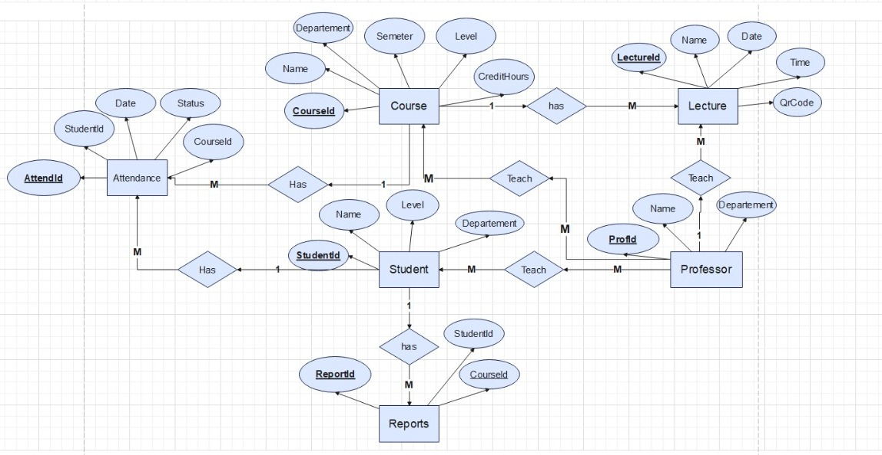

Fig (27): ERD

* 1. **Use case diagram:**

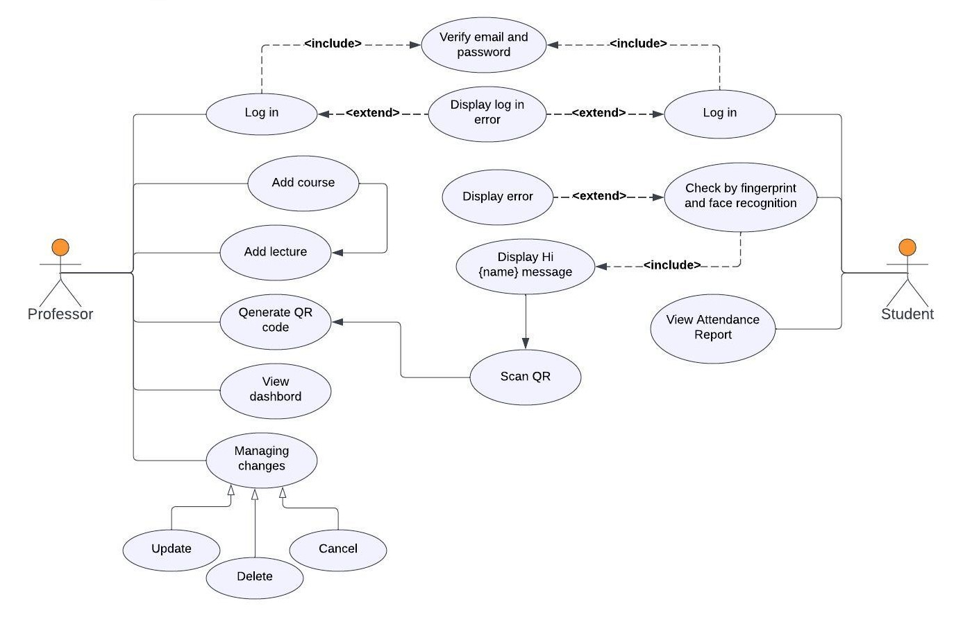

Fig (28): Use case diagram

* 1. **Use Case Scenarios:**
     1. **Sign up Use case scenarios:**

|  |  |  |
| --- | --- | --- |
| **Use case Name** | Sign up | |
| **Goal** | Create account | |
| **Primary actors** | User (Professor or Teaching Assistan or Student) | |
| **Secondary actors** |  | |
| **preconditions** | Connect to the internet User has E-mail | |
| **Post conditions** |  | |
| **Triggers** |  | |
| **Main Flow** | **Step** | **Actions** |
| **1** | Turn on data or WIFI |
| **2** | Open the system (app, web) |
| **3** | Click on the sign up |
| **4** | Enter information Requirements |
| **Extensions** | **4.1** | Check about email and password valid or invalid |

* + 1. **Log in Use case scenarios:**

|  |  |  |
| --- | --- | --- |
| **Use case Name** | Log in | |
| **Goal** | Log in to app | |
| **Primary actors** | User (Professor or Teaching Assistant or Student) | |
| **Secondary actors** |  | |
| **preconditions** | Connect to the internet  User has E-mail | |
| **Post conditions** |  | |
| **Triggers** |  | |
| **Main Flow** | **Step** | **Actions** |
| **1** | Turn on data or WIFI |
| **2** | Open the system (app, web) |
| **3** | Click on the login |
| **4** | Enter email and password |
| **Extensions** | **4.1** | Invalid email or password Enter again |

* + 1. **Verification of fingerprint**

|  |  |  |
| --- | --- | --- |
| **Use case Name** | Verification of fingerprint | |
| **Goal** | Verify the student’s fingerprint | |
| **Primary actors** | Student | |
| **Secondary actors** | None | |
| **preconditions** | Log in or sign up | |
| **Post conditions** |  | |
| **Triggers** | Authorization click Mobile fingerprint | |
| **Main Flow** | **Step** | **Actions** |
| **1** | Log in or sign up |
| **2** | Take fingerprint authorization |
|  |  |
| **Extensions** |  |  |

* + 1. **Verification of Face recognition**

|  |  |  |
| --- | --- | --- |
| **Use case Name** | Verification of Face recognition | |
| **Goal** | Verify the student’s face recognition | |
| **Primary actors** | Student | |
| **Secondary actors** | None | |
| **preconditions** | Log in or sign up | |
| **Post conditions** | Click on button | |
| **Triggers** | Authorization face recognition of student | |
| **Main Flow** | **Step** | **actions** |
| **1** | Log in or sign up |
| **2** | Take Face recognition authorization |
| **3** | Update database |
|  |  |
| **Extensions** |  |  |

* + 1. **Scan QR code**

|  |  |  |
| --- | --- | --- |
| **Use case Name** | Scan QR code | |
| **Goal** | Scan QR code to register attendance | |
| **Primary actors** | Student | |
| **Secondary actors** | None | |
| **preconditions** | Log in to the system and Verification of fingerprint or Face recognition | |
| **Post conditions** |  | |
| **Triggers** | Click to the button to scan | |
| **Main Flow** | **Step** | **actions** |
| **1** | Verification of fingerprint or Face recognition |
| **2** | Click to button |
| **3** | Scan the QR code |
| **Extensions** | **1.1** | 2.1 If confirmation is not confirmed by fingerprint or face |

* + 1. **Show dashboard (Student)**

|  |  |  |
| --- | --- | --- |
| **Use case Name** | Show dashboard | |
| **Goal** | To see how many times student is absent and present | |
| **Primary actors** | Student | |
| **Secondary actors** | None | |
| **preconditions** | Student registered attendance | |
| **Post conditions** |  | |
| **Triggers** | Scan QR code | |
| **Main Flow** | **Step** | **actions** |
| **1** | After scan QR code |
| **2** | System save in database |
| **3** | Only show dashboard Attendance |
| **Extensions** |  | |

* + 1. **Add course**

|  |  |  |
| --- | --- | --- |
| **Use case Name** | Add course | |
| **Goal** | Add a new course to the system | |
| **Primary actors** | Professor | |
| **Secondary actors** | None | |
| **preconditions** | Log in the system | |
| **Post conditions** | None | |
| **Triggers** | Professor clicks on "Add Course" button | |
| **Main Flow** | **Step** | **actions** |
| **1** | Click on "Add Course" button |
| **2** | System prompts the owner to fill out Course details |
| **3** | System validates new course information |
| **4** | System creates a new course |
| **5** | Update database |
|  | **6** | Display Successful Message |
| **Extensions** | **3.1** | Course Details are incorrect. Display The message "Unsuccessful" and display Course management option. |

* + 1. **Add lecture**

|  |  |  |
| --- | --- | --- |
| **Use case Name** | Add lecture | |
| **Goal** | Add lecture to a course | |
| **Primary actors** | Professor | |
| **Secondary actors** | Teaching Assistant | |
| **preconditions** | Log in the system | |
| **Post conditions** | None | |
| **Triggers** | Professor clicks on "Add Lecture" button | |
| **Main Flow** | **Step** | **actions** |
| **1** | Click on "Add Lecture" button |
| **2** | System prompts the owner to fill out Lecture details |
| **3** | System validates new lecture information |
| **4** | System creates a new Lecture |
| **5** | Update database |
|  | **6** | Display Successful Message |
| **Extension** | **3.1** | Lecture Details are incorrect. Display The message "Unsuccessful" and display Lecture management option. |

|  |  |  |
| --- | --- | --- |
| **Use case Name** | Generate OR code | |
| **Goal** | How generate OR code to scan by student | |
| **Primary actors** | Professor | |
| **Secondary actors** |  | |
| **preconditions** | Add lecture | |
| **Post conditions** |  | |
| **Triggers** | Professor clicks on "Generate" button. | |
| **Main Flow** | **Step** | **actions** |
| **1** | Professor select the course or create course |
| **2** | Click on " Generate " button |
| **3** | View QR code |
| **4** | Professor share QR code with student |
| **Extensions** |  |  |

* + 1. **Generate OR code**
    2. **Show dashboard**

|  |  |  |
| --- | --- | --- |
| **Use case Name** | Show dashboard | |
| **Goal** | To see how many times student is absent and present | |
| **Primary actors** | Professor | |
| **Secondary actors** | Teaching Assistant | |
| **Preconditions** | Student registered attendance | |
| **Post conditions** |  | |
| **Triggers** | Student scan QR code | |
| **Main Flow** | **Step** | **actions** |
| **1** | After scan QR code |
| **2** | System save in database |
| **3** | Professor can show, update and delete dashboard Attendance |
| **Extensions** |  | |

* + 1. **Update Course**

|  |  |  |
| --- | --- | --- |
| **Use case Name** | Update Course | |
| **Goal** | Update course properties | |
| **Primary actors** | Professor | |
| **Secondary actors** |  | |
| **preconditions** | Log in the system | |
| **Post conditions** | None | |
| **Triggers** | Professor clicks on "Update Course" button. | |
| **Main Flow** | **Step** | **actions** |
| **1** | Click on "Update Course" button |
| **2** | System prompts professor to select course |
| **3** | Professor select the course |
| **4** | System display course properties |
| **5** | Professor update course properties |
| **6** | Update from database |
| **7** | Display Successful Message |
| **Extensions** |  |  |

* + 1. **Update Lecture**

|  |  |  |
| --- | --- | --- |
| **Use case Name** | Update Lecture | |
| **Goal** | Update lecture properties | |
| **Primary actors** | Professor | |
| **Secondary actors** |  | |
| **preconditions** | Log in the system | |
| **Post conditions** | None | |
| **Triggers** | Professor clicks on "Update Lecture" button. | |
| **Main Flow** | **Step** | **actions** |
| **1** | Click on "Update Lecture" button |
| **2** | System prompts professor to select lecture |
| **3** | Professor select the lecture |
| **4** | System display lecture properties |
| **5** | Professor update lecture properties |
| **6** | Update from database |
| **7** | Display Successful Message |
| **Extensions** |  | |

* + 1. **Delete Course**

|  |  |  |
| --- | --- | --- |
| **Use case Name** | Delete Course | |
| **Goal** | Delete course properties | |
| **Primary actors** | Professor | |
| **Secondary actors** |  | |
| **preconditions** | Log in the system | |
| **Post conditions** | None | |
| **Triggers** | Professor clicks on "Delete Course" button. | |
| **Main Flow** | **Step** | **actions** |
| **1** | Professor select the course |
| **2** | Click on "Delete Course" button |
| **3** | System display options (yes or no) |
| **4** | Professor delete course (yes) or cancel (no) |
| **5** | Delete from database |
| **6** | Display Successful Message |
| **Extensions** |  |  |

* + 1. **Delete Lecture**

|  |  |  |
| --- | --- | --- |
| **Use case Name** | Delete Lecture | |
| **Goal** | Delete lecture properties | |
| **Primary actors** | Professor | |
| **Secondary actors** |  | |
| **preconditions** | Log in the system | |
| **Post conditions** | None | |
| **Triggers** | Professor clicks on "Delete Lecture" button. | |
| **Main Flow** | **Step** | **actions** |
| **1** | Professor select the lecture |
| **2** | Click on "Delete Lecture" button |
| **3** | System display options (yes or no) |
| **4** | Professor delete lecture (yes) or cancel (no) |
| **5** | Delete from database |
| **6** | Display Successful Message |
| **Extensions** |  |  |

* 1. **Activity Diagram**
     1. **Sign up user (web - app)**

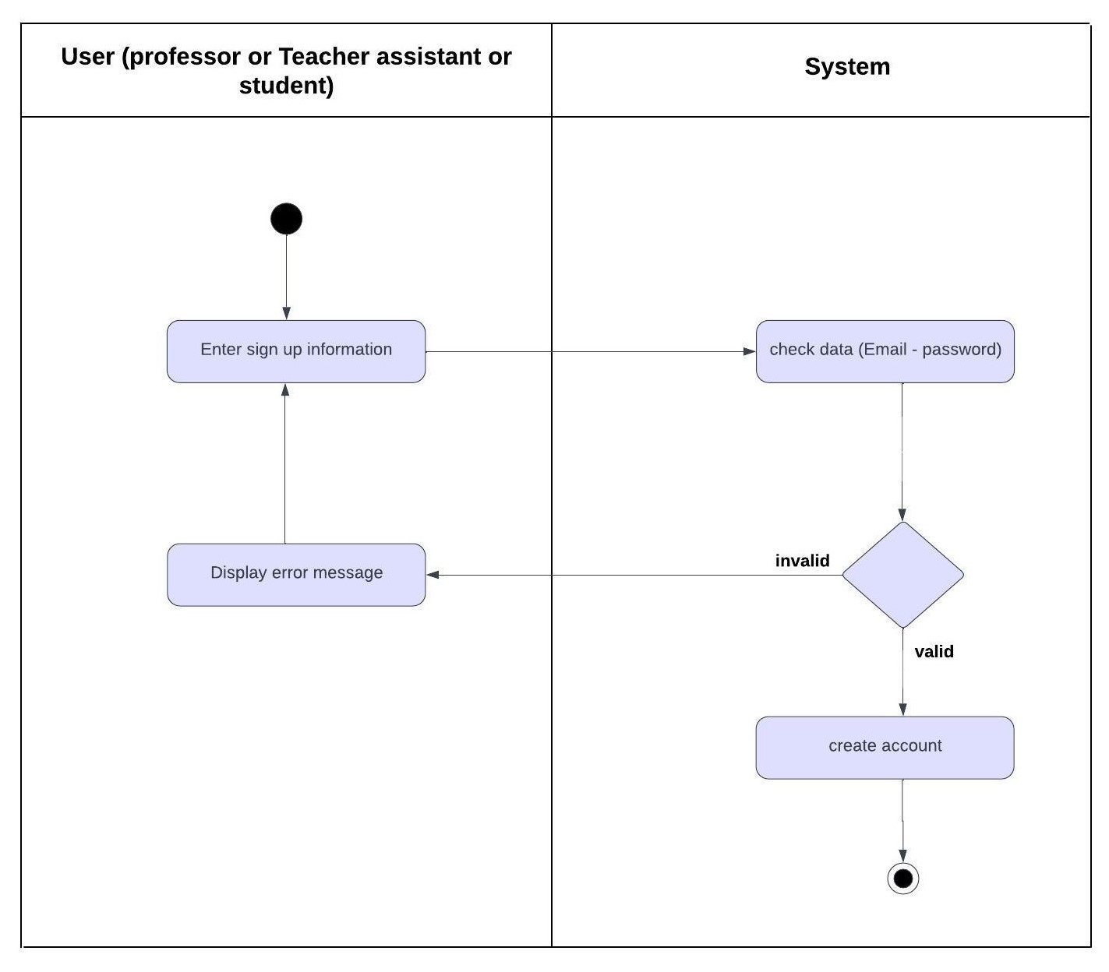

Fig (29): Sign up

**4.4.2. Log in user (web - app)**

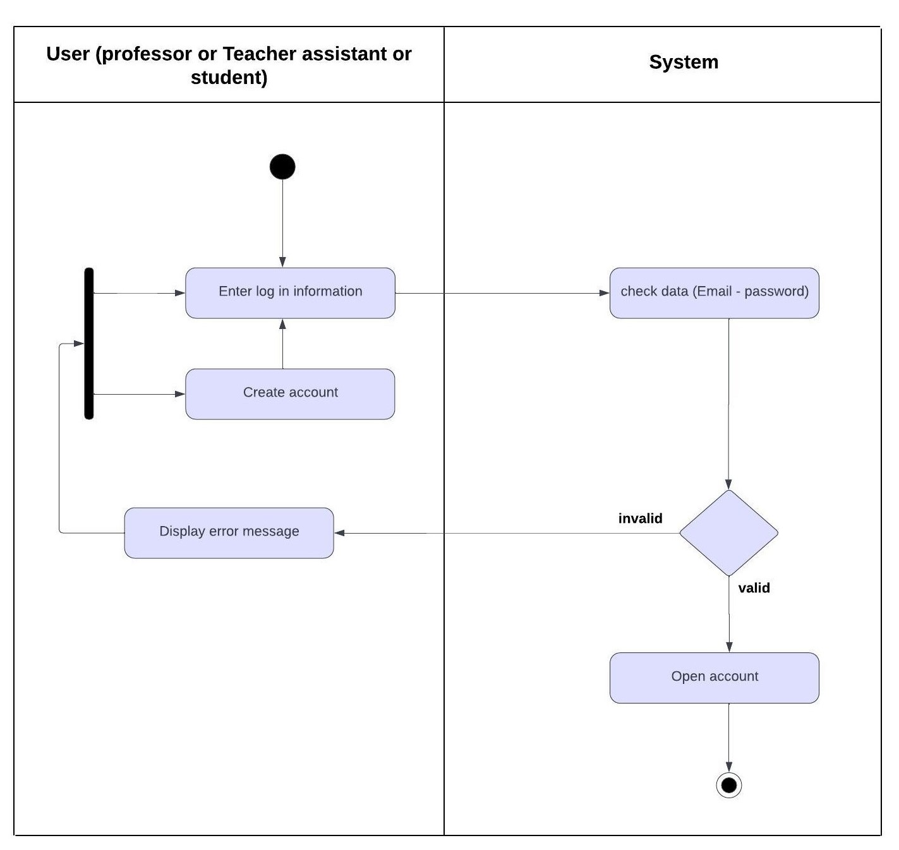

Fig (30): Log in

**4.4.3. Professor add course**

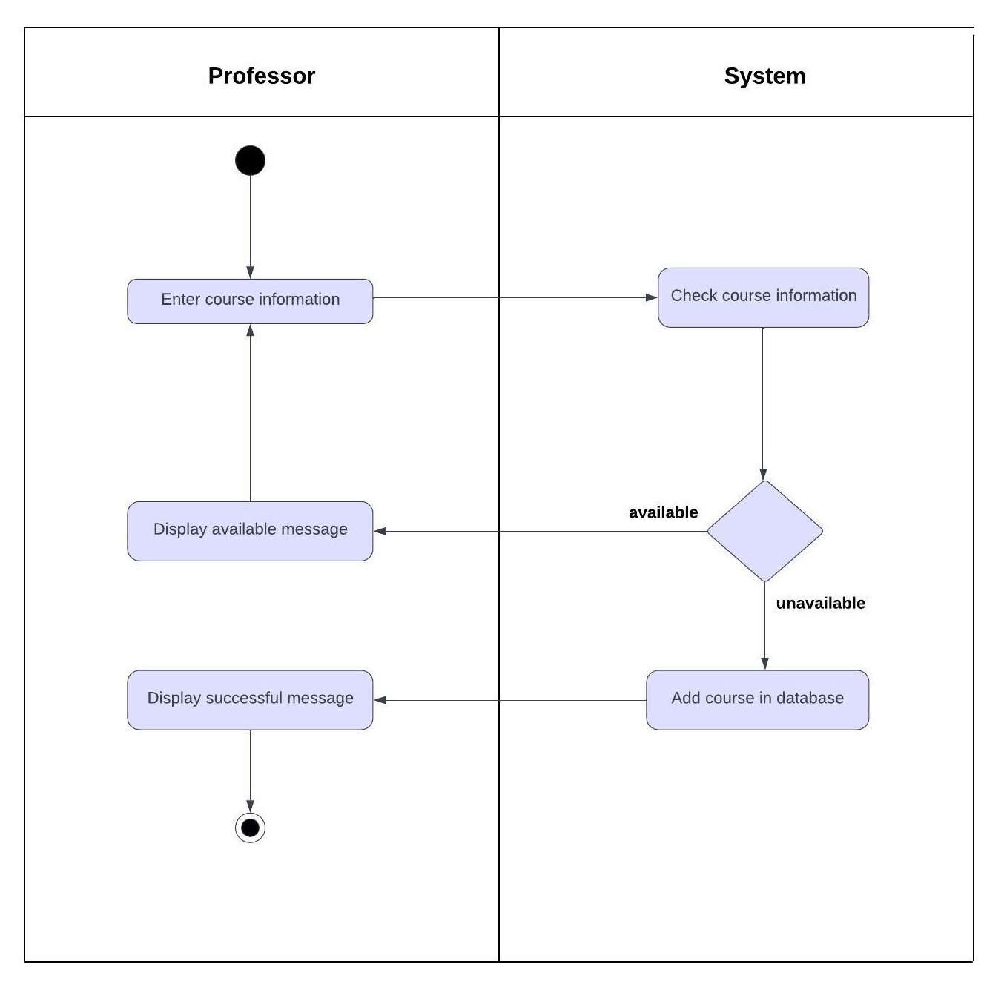

Fig (31): Add course

**4.4.4 Professor add lecture**

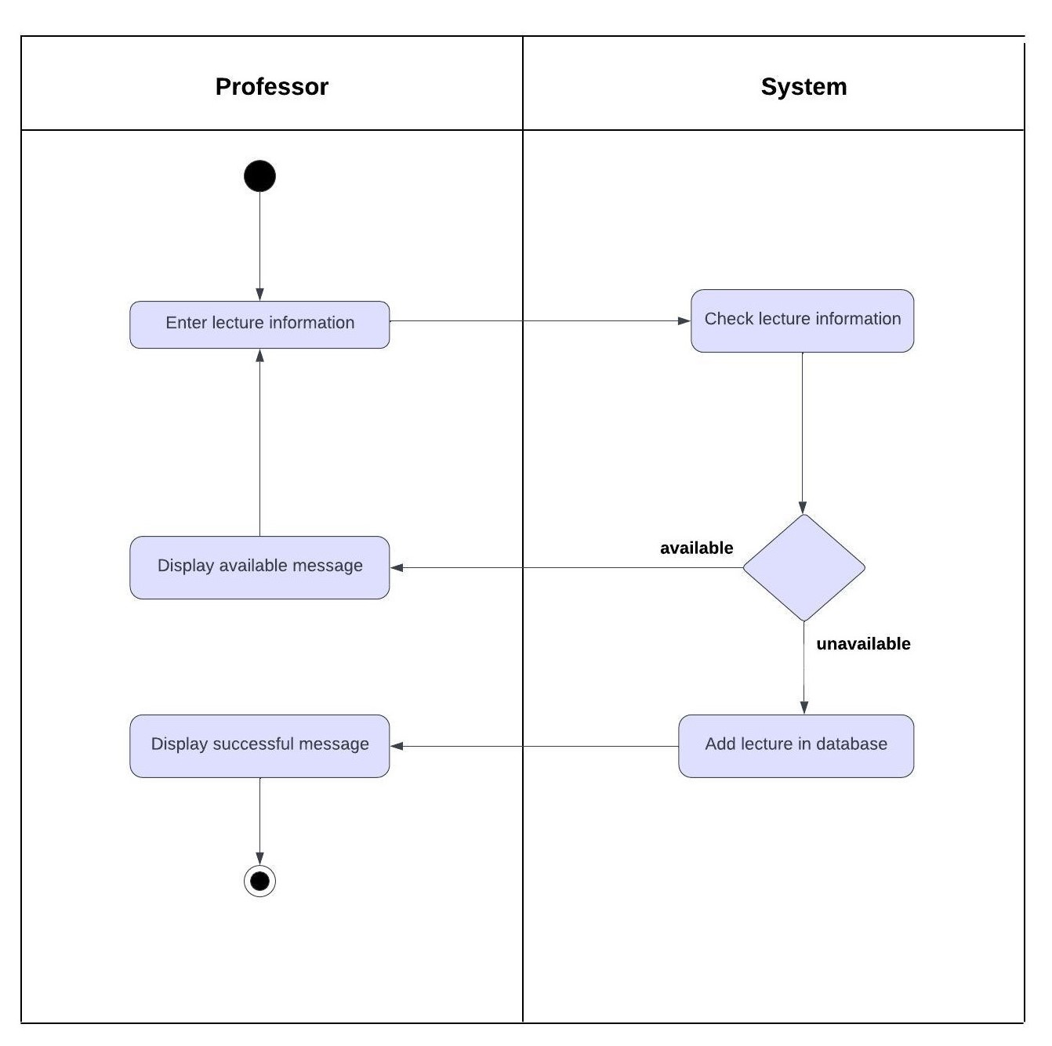

Fig (32): Add lecture

**4.4.5. Professor update course**

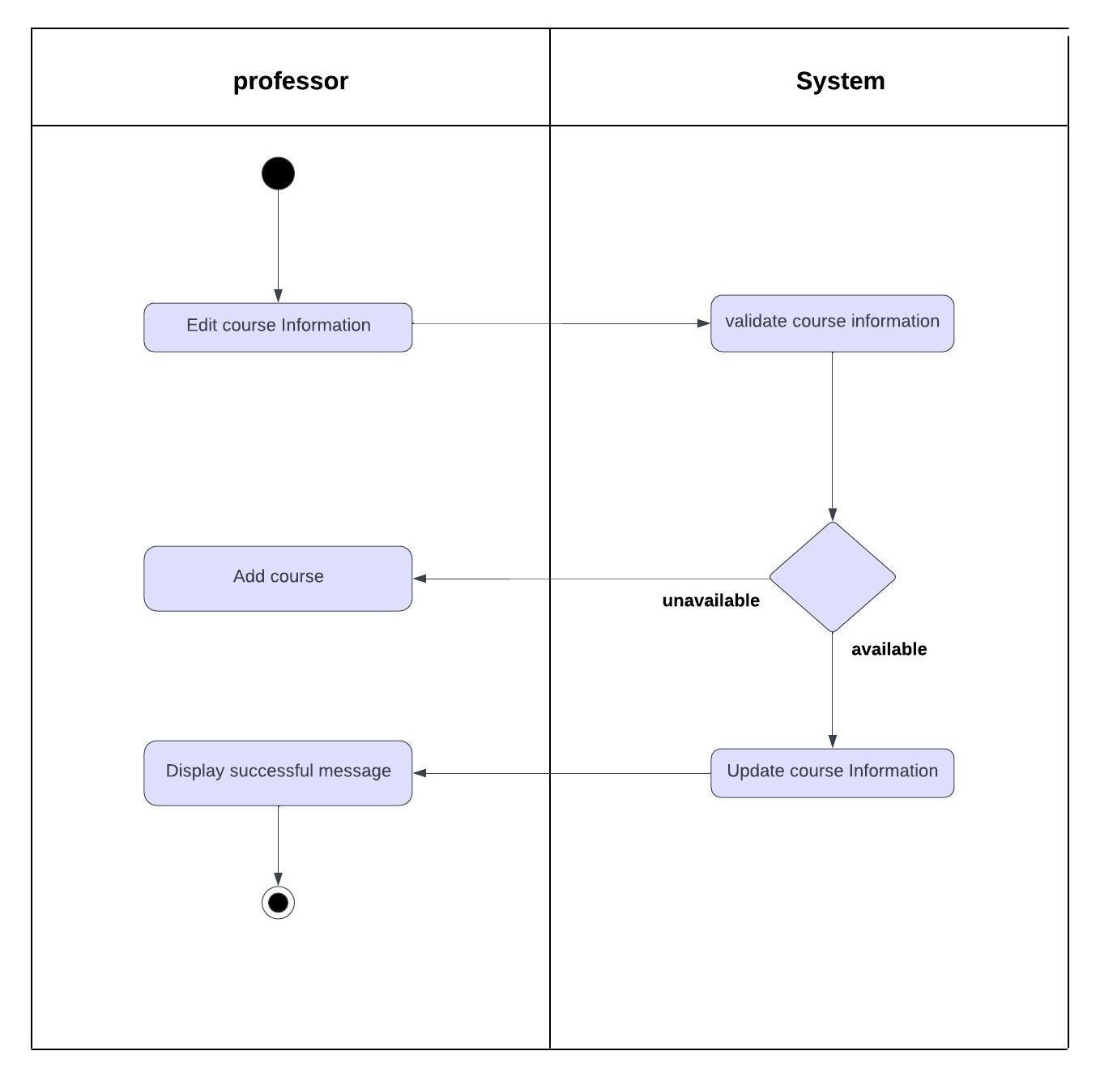

Fig (33): Update course

**4.4.6. Professor update lecture**

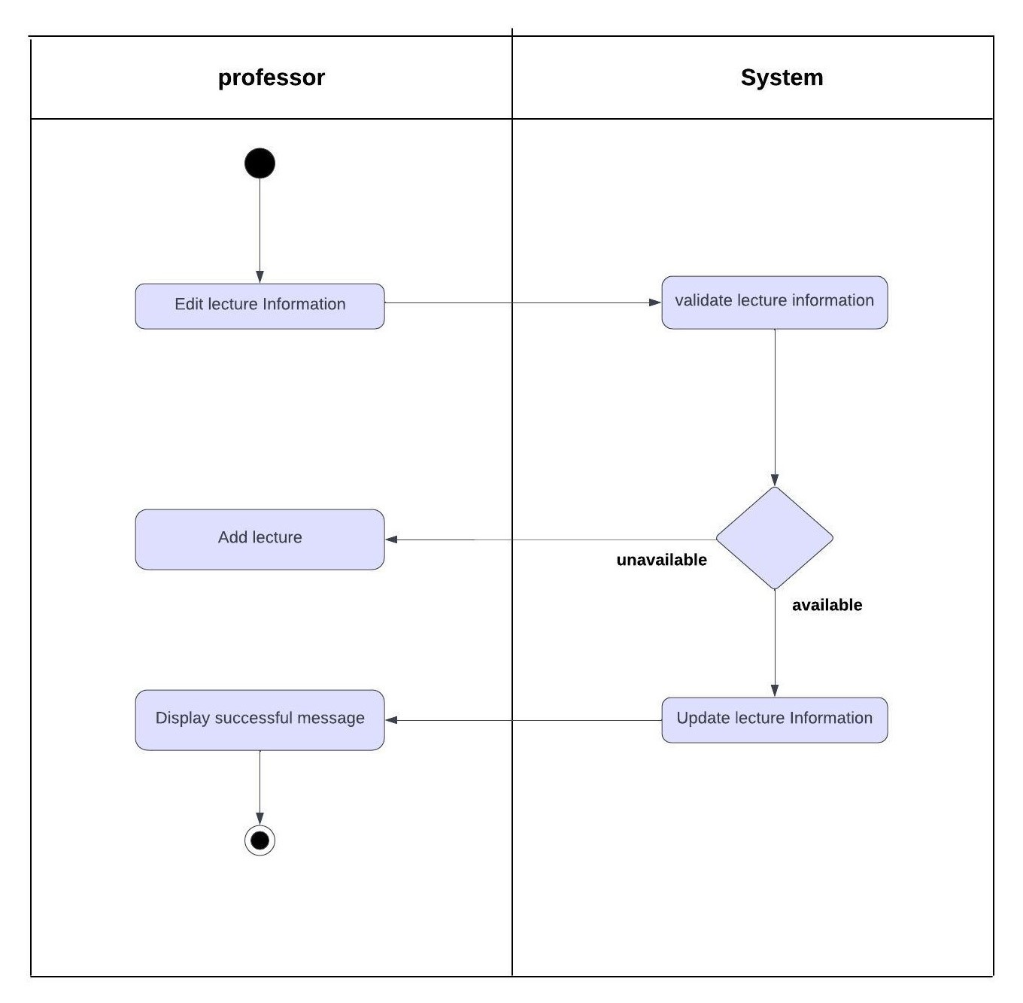

Fig (34): Update lecture

**4.4.7. Professor delete course**

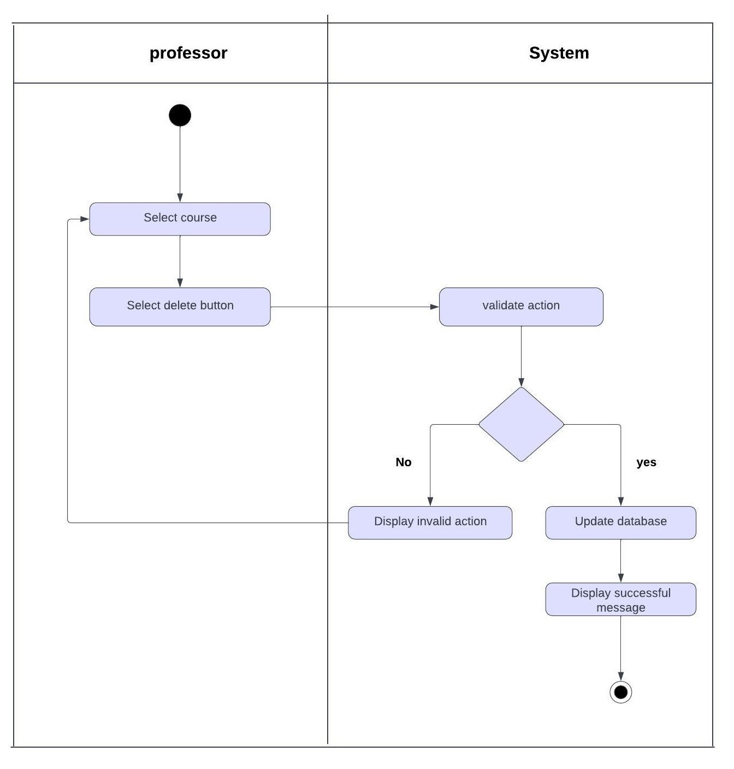

Fig (35): Delete course

**4.4.8. Professor delete lecture**

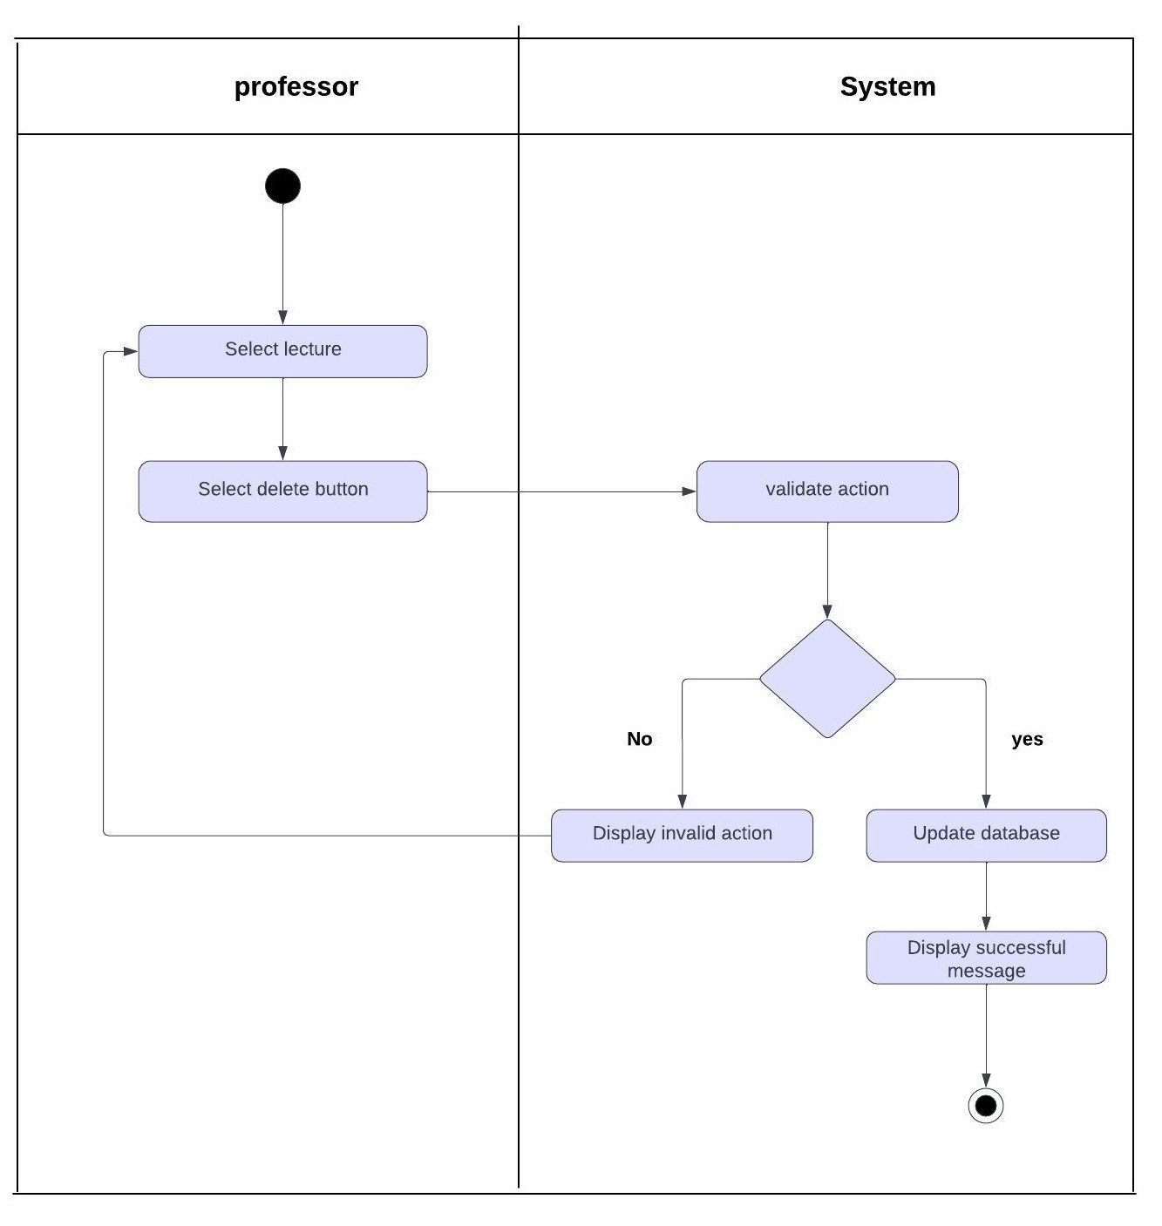

Fig (36): Delete lecture

**4.4.9. Professor generate QR code**

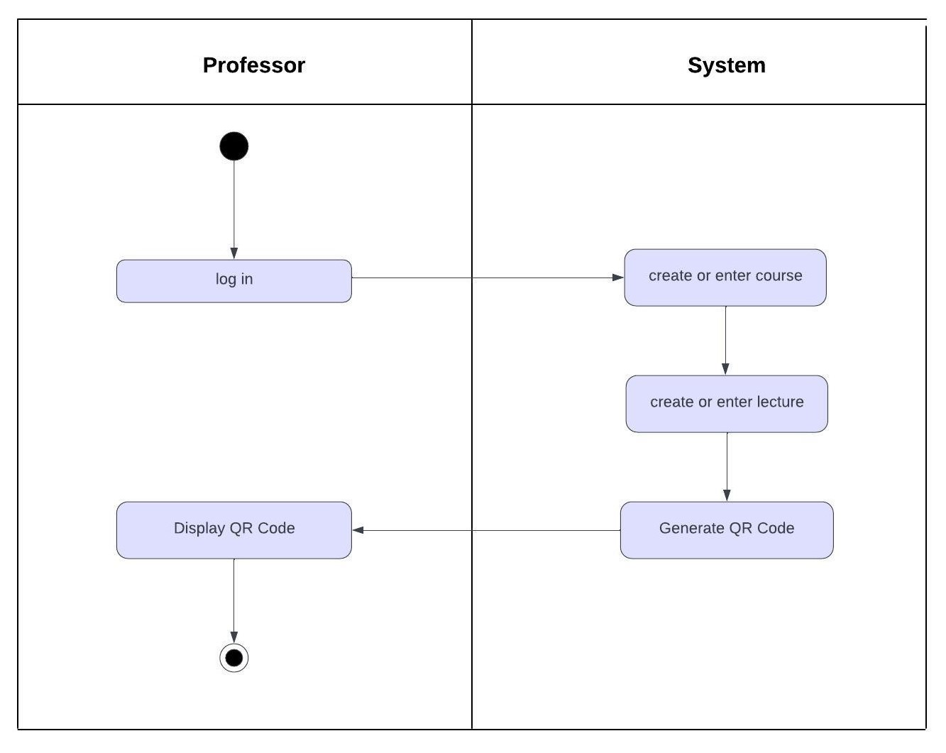

Fig (37): Generate QR code

**4.4.10. Face recognition (student)**

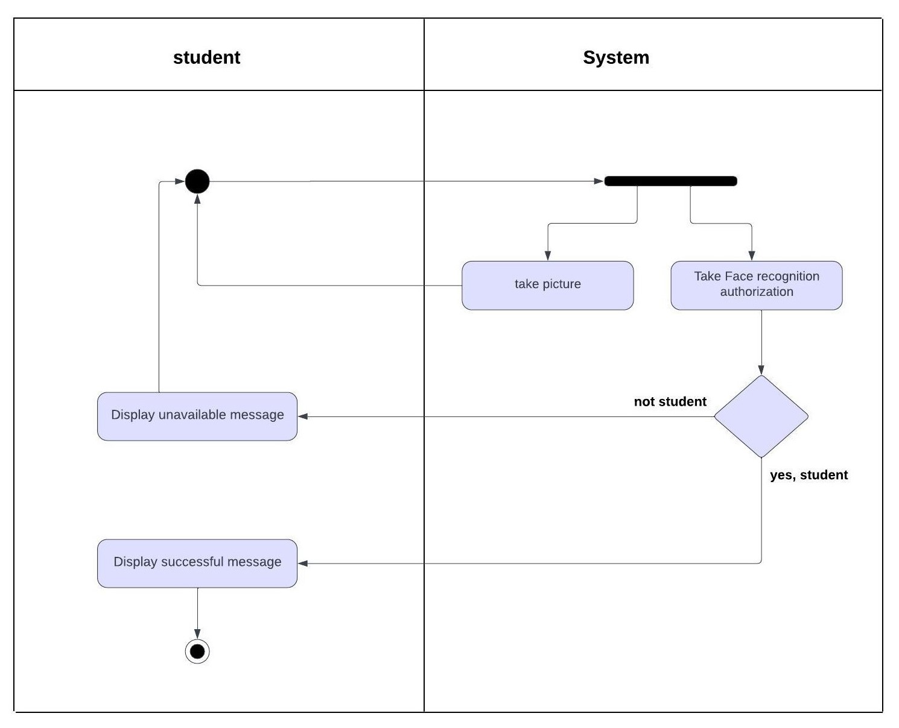

Fig (38): Face recognition

**4.4.11. finger print (student)**

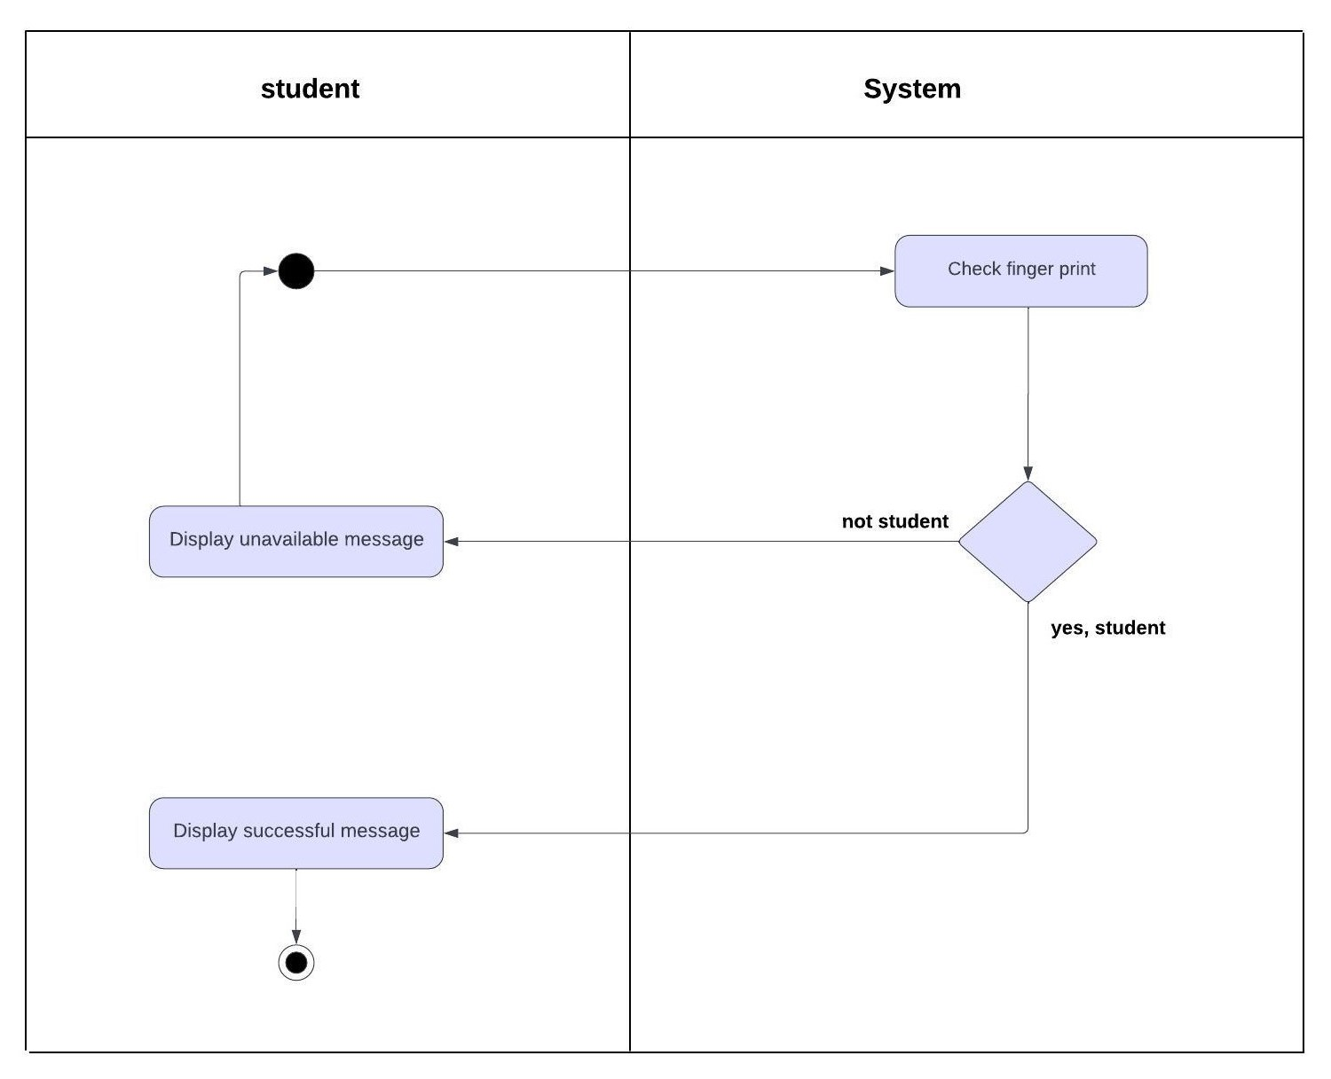

Fig (39): Finger print

**4.4.12 Student scans QR code**

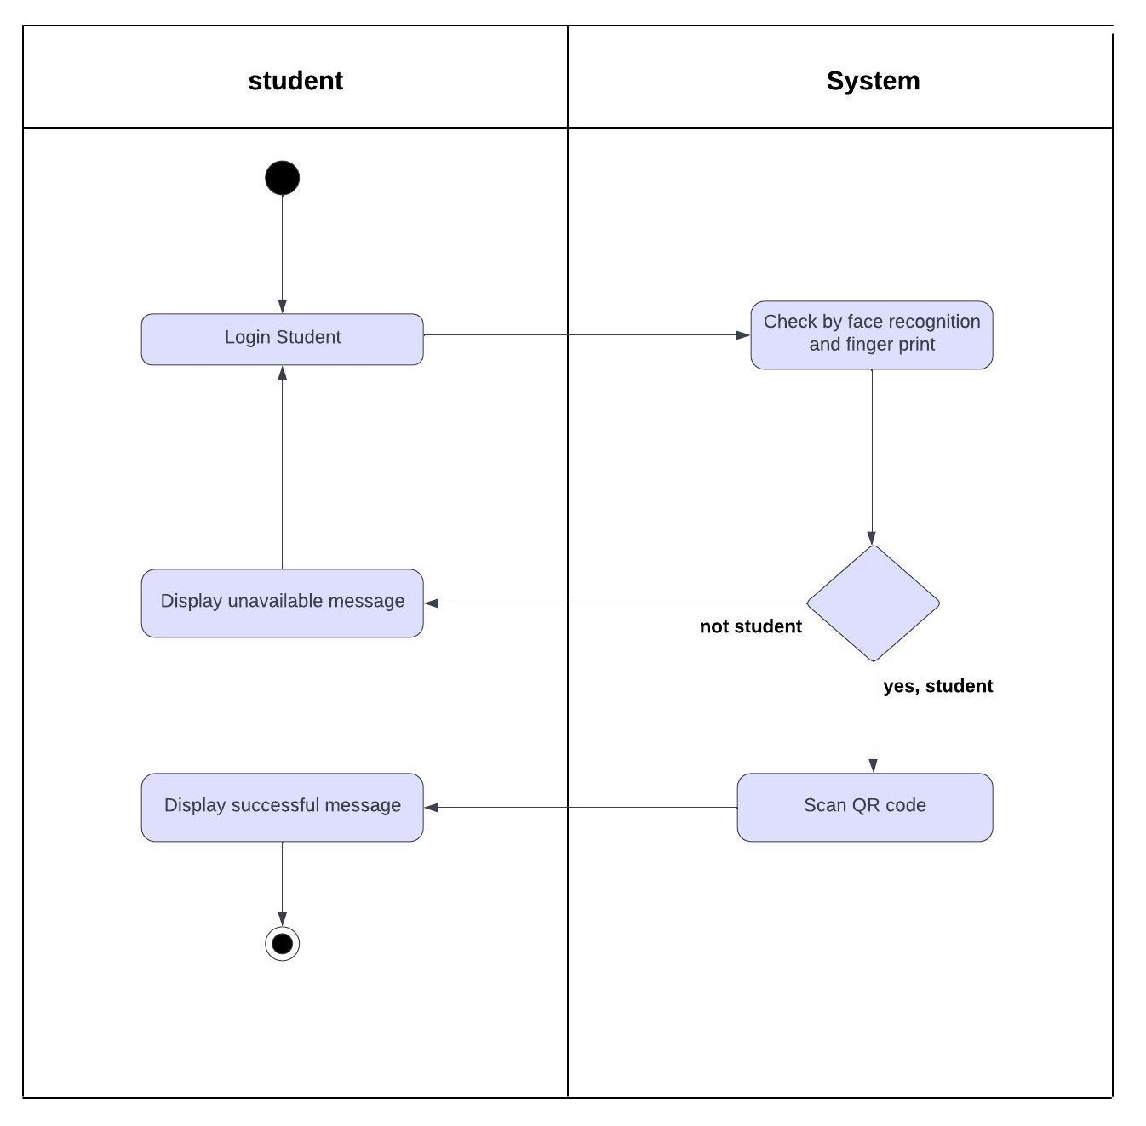

Fig (40): Scan QR code